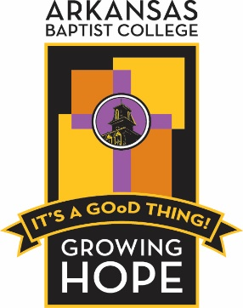

Office of Institutional Advancement
1600 Dr. Martin Luther King Jr. Drive • Little Rock, Arkansas 72202
Telephone: 501-420-1206 • Fax: 501-414-0861 • www.arkansasbaptist.edu
A Day of Giving Radiothon
Friday, May 21,2021
Buffalo Radio
Scott Ford Center

Dear Alumni, Parents, and Friends,
It is with great pleasure that we officially kick off “A Day of Giving” with many activities using our Internet Buffalo Radio Station. Our college began with a handful of Baptist Ministers who worked hard to build a sound Baptist educational foundation for everyone.
Today’s Arkansas Baptist College continues to reach further into the future by augmenting stellar teaching with cutting edge technology. We continue to hold fast to that which made us great and reach forward for that which will make us better.
Your donation will allow Arkansas Baptist College to build upon its long-standing legacy of educating the next generation of leaders. The number one obstacle for our students continues to be the cost of acquiring a college education. Your donation will enable the College to keep the cost of tuition as low as possible and provide financial assistance to the most deserving students.
Please, celebrate with us on this day of giving by making a generous donation to the college for student scholarships. Visit our website and like our social media posts about our history, college, activities and highlights of the personnel we interview on our radio station.
Please consider a donation today by going to our website and clicking on “Give to ABC”, or use our TEXT to Give, or drop by the Buffalo Radio Station, participate in a live interview and bring your donation.
We appreciate all donations and no donation is too small!
Thank you in advance for your donation.

Sincerely,

Jeff Sellers
Vice President of Institutional Advancement
Arkansas Baptist College
501-420-1206
www.arkansasbaptist.edu

