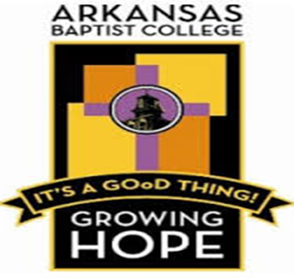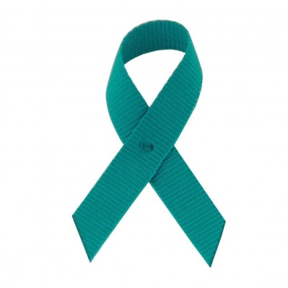
Sexual Assault Awareness Week
April 12-16. 2021
Theme: “Not On My Campus”
Quiz on Sexual Assault Prevention & Intervention

Name_______________________________________________________________________

Instructions: Provide your responses to each of the questions below:
- More than half a million young girls and women in America are sexually assaulted each year: True or False
- It is estimated that one (1) in six (6) men will be a victim of rape in his lifetime: True or False
- Sexual Assault/Rape is about power and control: True or False
- Approximately 75% of all Rapes are committed by someone the victim knows: True or False
- Rape is a Crime: True or False
- Every _________seconds, 1.3 women (18+) in the U. S. are forcibly raped.
- Each year, _________________ women in the U.S. are forcibly raped.
- There are currently _____________registered sex offenders in Arkansas.
- In the U.S. __________ is the most costly crime to its victims totally $127 Billion per year in medical costs, lost earnings, pain & suffering and best quality of life.
- Most _____________ are serial offenders.
- __________% of all rapes are made by 6% of males.
- Most abusers appear to be “______________.”
- Most __________ ____________are perpetrated by someone the victim knows.
- _________________ is a victim regardless of age, gender, race, religion, occupation, education or physical description.
- _____________ ______________ is the term used to describe nonconsensual sexual acts between a woman and her husband, ex-husband, or intimate long-term partner.

Prizes:
20/20 = First Place $25
19/20 = Second Place $15
18/20 = Third Place $10

Submit Completed Quiz to: vicki.williams@arkansasbaptist.edu

